Select App Engine -> Dashboard -> Application(First Application if it is first) -> Language(java/python)

Step 1. Configure App Engine on your Project

Create Your Project under GCP default (My First Project)

Open Cloud Shell is a built-in command line tool for the console.

Create Repository by following below steps:

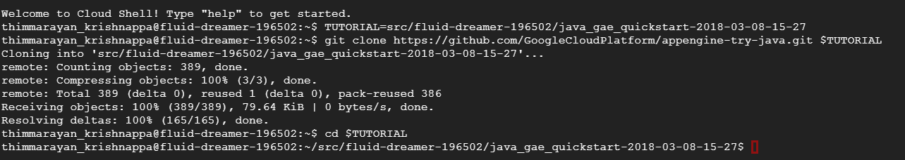

Build the AppEnging application using maven

mvn appengine:run

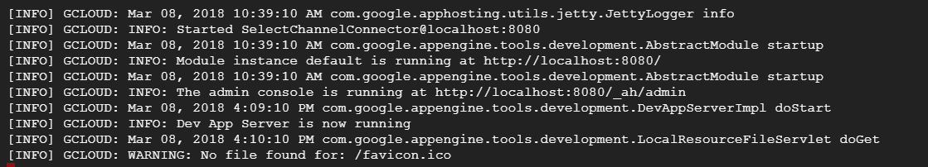

Access web by clicking <http://localhost:8080/>

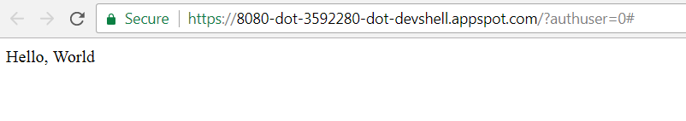

GCP Configuration in Local Desktop to access app Engine:

Step 1: download the App Engine SDK from GCP App-Engine Dashboard console

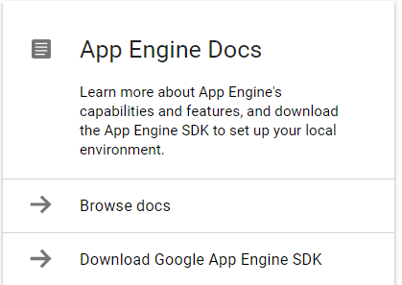

Step 2: Download the Google Cloud SDK installer for windows and install follow the standard process to install by Accepting license and selecting all User until Finish.

url: [https://cloud.google.com/sdk/docs/quickstart-windows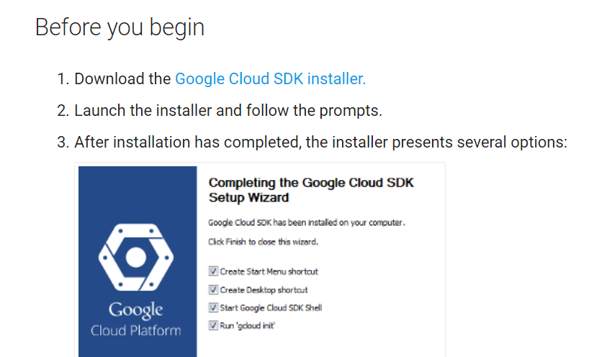](https://cloud.google.com/sdk/docs/quickstart-windows#)

Configure the gcloud command-line environment:

gcloud init

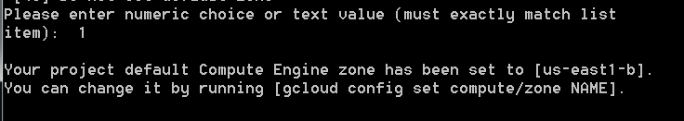

Login GCP account and allow to access for authentication

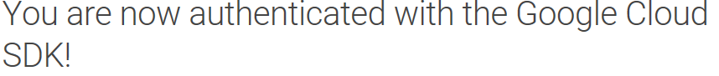

Authenticate the gcloud login details by providing the account, project and region details.

gcloud auth application-default login

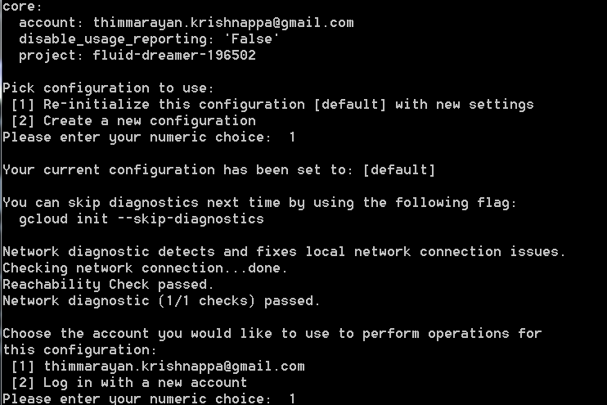

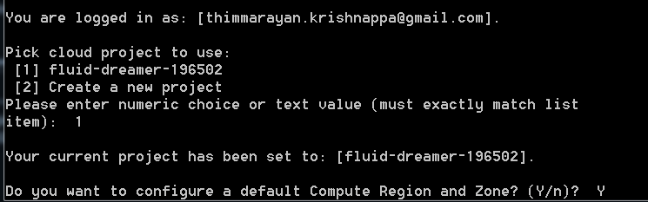



Open the gcloud console will find in the windows start menu then

Install the App Engine component:

gcloud components install app-engine-java

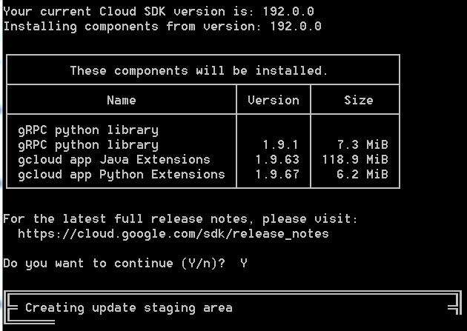

Install maven and set system path in environment variable and JAVA_HOME should set correct to access the maven.

url: <https://maven.apache.org/download.cgi>

tar xzvf apache-maven-3.5.2-bin.tar.gz

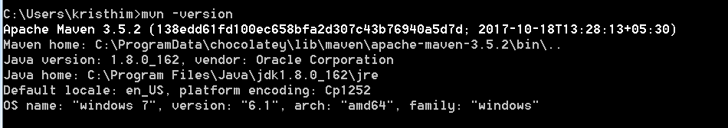

Download and Install GitHub in your local machine, once installation complete register the GitHub public repository for free by providing your details.

<https://desktop.github.com/>

Right click on your desktop to open the GitBash console.

Clone the Hello World sample app repository to your local machine:

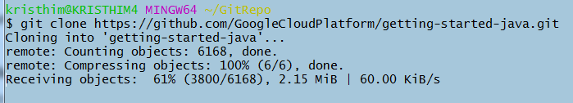

Change to the directory that contains the sample code:



Start the local Jetty web server using the Jetty Maven plugin

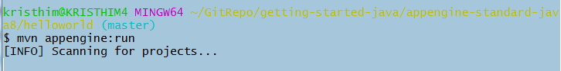

Access the website using http:/localhost:8080/